CSA1616 - DATA WAREHOUSING AND DATA MINING
Lab Experiments (14 & 15)
Name: Pravin R
Reg. No: 192421292
Date: 15/10/2026

Experiment - 14
Aim:
To compare the performance of two classes using mean, median, and range, and to visualize the marks using a box plot
Code:
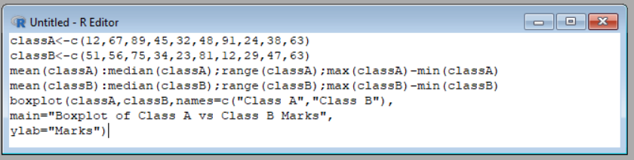
Output:
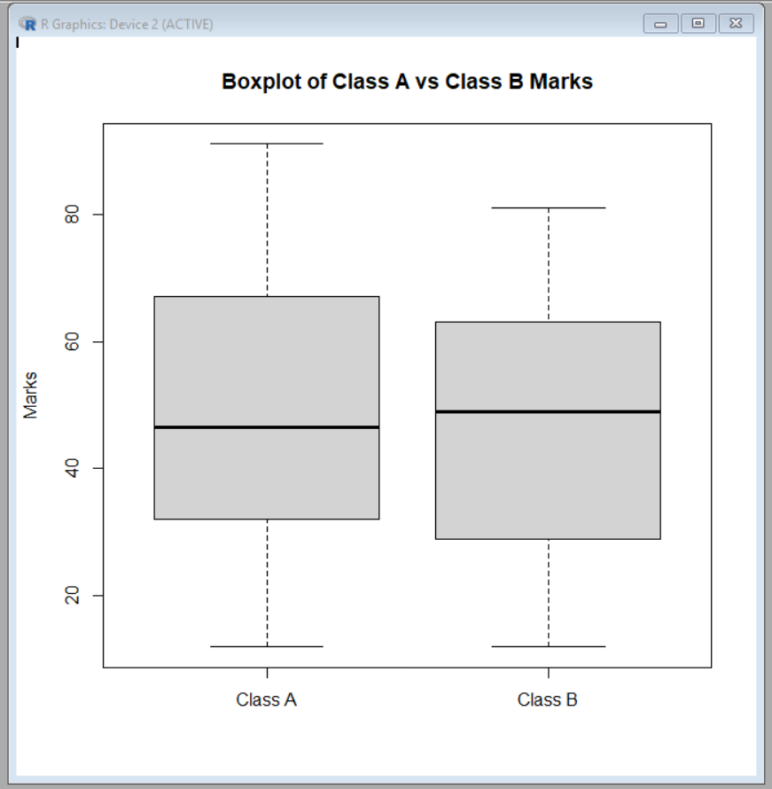
Result:
It is executed successfully.
Experiment - 15
Aim:
To apply min-max normalization and z score normalization on the given data to scale the values
Code:
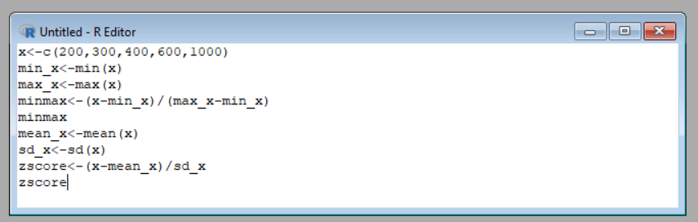
Output:
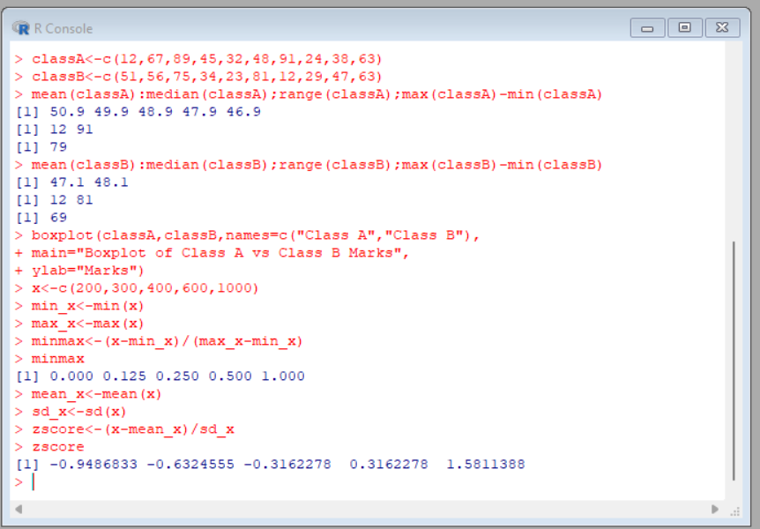
Result:
It is executed successfully.

